University of Virginia
Psychology Minor Checklist (New Requirements)
For students who matriculated after Spring 2018
For complete requirements visit: https://psychology.as.virginia.edu/psychology-minor

- PREREQUISITES: These courses (taken in any order) are needed to declare the major (equivalent AP, IB and transfer courses may be used):
PSYC 2005 (at least C) Research Methods & Data Analysis I
Two 2000-level PSYC course (at least C, from any pillars, can include PSYC-1010 including transfer equivalents or AP 3 or IB high-level 4, or standard-level 5)
UVA PSYC GPA of at least 2.00 (for all psychology courses already taken at UVA)

- STAY INFORMED: Sign up on COLLAB (this step is required when you declare the major or minor)
Join the Collab site “Psych Majors/Minors”
Add yourself to the group for your graduation year (under “settings” section)
Complete the “Major/Minor Declaration (or deferral) Questionnaire” (in “tests/quizzes” section)

- MINOR REQUIREMENTS (PSYC): |  | Semester | Year | Transfer?  (6 max) | Required Credits | Earned Credits
 | PSYC 2005 (Research Methods & Data Analysis I) |  |  |  | 3
 | PSYC 2000-level |  |  |  | 3
 | PSYC 2000-level |  |  |  | 3
 | PSYC 2000+ |  |  |  | 3
 | PSYC 3000+ |  |  |  | 3
 | PSYC 3000+ |  |  |  | 3
 | Totals |  |  |  | 18
 | UVA PSYC GPA must be at least 2.00, UVA PSYC GPA =

- Credit Hour Requirements: 18 credit hours.
- Grade Standards: Must earn at least a “C” in all courses counting toward the minor. Overall UVA PSYC GPA of at least 2.00. Students receiving grades of “C -” (C minus) or lower in three psychology courses and who have less than a 2.0 GPA in all psychology classes will not be permitted to continue in the minor. The dept. of Psychology uses all PSYC courses taken at UVA including repeated courses for the GPA calculation.
- Courses that do not count toward the minor: PSYC-3590, Research in Psychology, Directed Readings in Psychology, PSYC Internship.
- Transfer Credit: A maximum of 6 transfer credits can be used toward the minor. Courses at the 2000-level are most suitable for transfer. Credit toward the minor may be given for substantial courses, even if a comparable course is not offered in this department. Transfer credits for PSYC 2005/3005/3006 or 4000- or 5000-level courses are difficult to obtain and are not recommended for transfer.
- Questions: Undergraduate Coordinator, Lisa Ishler, psy-info@virginia.edu , (434) 982-4981

Last revised: 10/15/2021
Psychology Advising and Resources

Meet our Students  https://psychology.as.virginia.edu/meet-our-students | How to Declare the Minor  https://psychology.as.virginia.edu/psychology-minor | Psychology Website  https://psychology.as.virginia.edu

Lisa Ishler – Undergraduate Coordinator

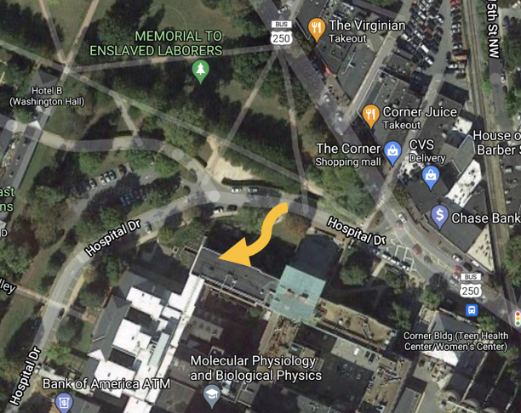
- Telephone: (434) 982-4981 The fastest way to reach me is by giving me a call during business hours. If I am not available, please leave a message with your name and number and I will return your call as soon as possible.​

- Email: psy-info@virginia.edu

- Open Office Hours - Weekdays between 2 – 4 pm. No appointment needed - ​Give me a call (434) 982-4981 or stop by my office. Check the website for out-of-office notices: https://psychology.as.virginia.edu/department-contacts

- Office Location: Psychology Corner Location - Hospital Drive - West Complex Building – Suite 2519C: You can access our building from the Corner, if you cross the street near Mincers or CVS you will see our building (West Complex), find the Psychology Dept sign post along Hospital Drive, and follow the small sidewalk that is slightly winding to the lower right hand side of the face of the building (the map below shows the general area). Once you enter you will see “Welcome Students” signs that lead you to Suite 2519 – Academic Advising Offices.

Chris Mazurek, PhD - Director of Undergraduate Studies
Email: cjm5ma@virginia.edu
Office Location: Psychology Corner Location - Hospital Drive - West Complex Building – Suite 2519D

